Abstract-These instructions give you basic guidelines for preparing camera-ready papers for theEHE2011 - International Conference on Electromagnetic Fields, Health and Environment, to be held in Coimbra, Portugal, from 26th to 28th of May, 2011. Please, replace XXX by your paper ID in the header of the document and select a category number accordingly to the thematic areas numeration.
Preparation of Papers in Two Column Format for
EHE2014 Conference Proceedings
First A. Author, Second B. Author, and Third C. Author
Affiliation
Street Address, Postal Code, Country
E-mail Address

Introduction
Your goal is to simulate the usual appearance of papers in an IEEE conference proceeding. For items not addressed in these instructions, please refer to the last issue of your conference’s proceedings or your Publications chair.
On the last page of your paper, adjust the lengths of the columns so that they are equal. Use automatic hyphenation and check spelling. Digitize or paste down figures.
Please prepare the camera–ready copy on regular size paper (8.5in x 11in = 21.6cm x27.9cm) or A4 paper (21.0cm x29.7cm). The digest should be prepared in double-column format. The total text height should be 9.6in (24.4cm). The total width should be 7.2in (18.3cm) with a separation of 0.2in (0.5cm) between the columns. Please provide a top margin of 0.7in (1.8cm) and a left margin of 0.65in (1.65cm). Paragraphs follow the indented paragraph format with left and right justification. Use 0.2in (0.5cm) for paragraph indentation. Don’t leave space between the paragraphs.
Please number section headings with Roman numerals and center them in column. The spacing before and after the section headings should be 12pt and 4pt, respectively. Please number the subheadings with alphabetical letters. The spacing before and after the subheadings is 6pt and 3pt, respectively. The indentation for subheadings is 0.1in.
Left- and right-justify your columns. Use tables and figures to adjust column length. On the last page of your paper, adjust the lengths of the columns so that they are equal. Use automatic hyphenation and check spelling. Digitize or paste down figures.

Type and Size of Fonts
Please use Times New Roman typeface and following the type size specified in Table I as closely as possible.
TABLE I
TYPES SIZES FOR CAMERA-READY PAPERS
Item | Type Size  (points) | Appearance
Title | 14 | Bold
Author’s Name | 12 | Regular
Author’s Affiliations ,mailing address, and E-mail | 10 | Regular
Abstract | 9 | Bold
Sections Titles | 10 | Small capitals, centered in column, Roman Numerals
Subheadings | 10 | Italics, alphabetical numerals
Main Text | 10 | Regular
Subscripts and Superscripts in the Main Text | 8 | Regular
Equations | 10 | Regular
Figure Captions | 8 | Regular, centered in column, Arabic numerals
Table Captions | 10 | Small capitals, title case, centered in column, Roman numerals
Table Name/Description | 8 | Small capitals, title case, centered in column, Roman numerals
Table Text | 8 | Regular
Subscripts and Superscripts in Table Text | 6 | Regular
References | 8 | Regular

Useful Hints

Figures and tables
Place figures and tables in the middle of columns. Figure captions should be centered below the figures; table captions should be centered above the tables. Please use words rather than symbols to label the axis. As an example, write the quantity “Magnetization,” or “Magnetization, M,” not just “M.” Put units in parentheses. Do not label axes only with units. As in Fig. 1, for example, write “Magnetization (A/m)” or “Magnetization (Am⁻¹),” not just “A/m.” Do not label axes with a ratio of quantities and units. For example, write “Temperature (K),” not “Temperature/K.” Multipliers can be especially confusing. Write “Magnetization (kA/m)” or “Magnetization (10³A/m).” Do not write “Magnetization (A/m1000)” because the readers would not know whether the top axis label in Fig. 1 meant 15000A/m or 0.015A/m.
Figure labels should be legible, approximately 8 to 12 point type when reduced to column width. Note that “Fig.” is abbreviated. There is a period after the figure number, followed by two spaces.

Abbreviations and Acronyms
Define abbreviations and acronyms the first time they are used, even after they have been defined in the abstract. Abbreviations such as IEEE, SI, MKS, CCG, ac, and dc do not have to be defined. Don’t use abbreviations in the title unless they are unavoidable (for example, the title of this article).

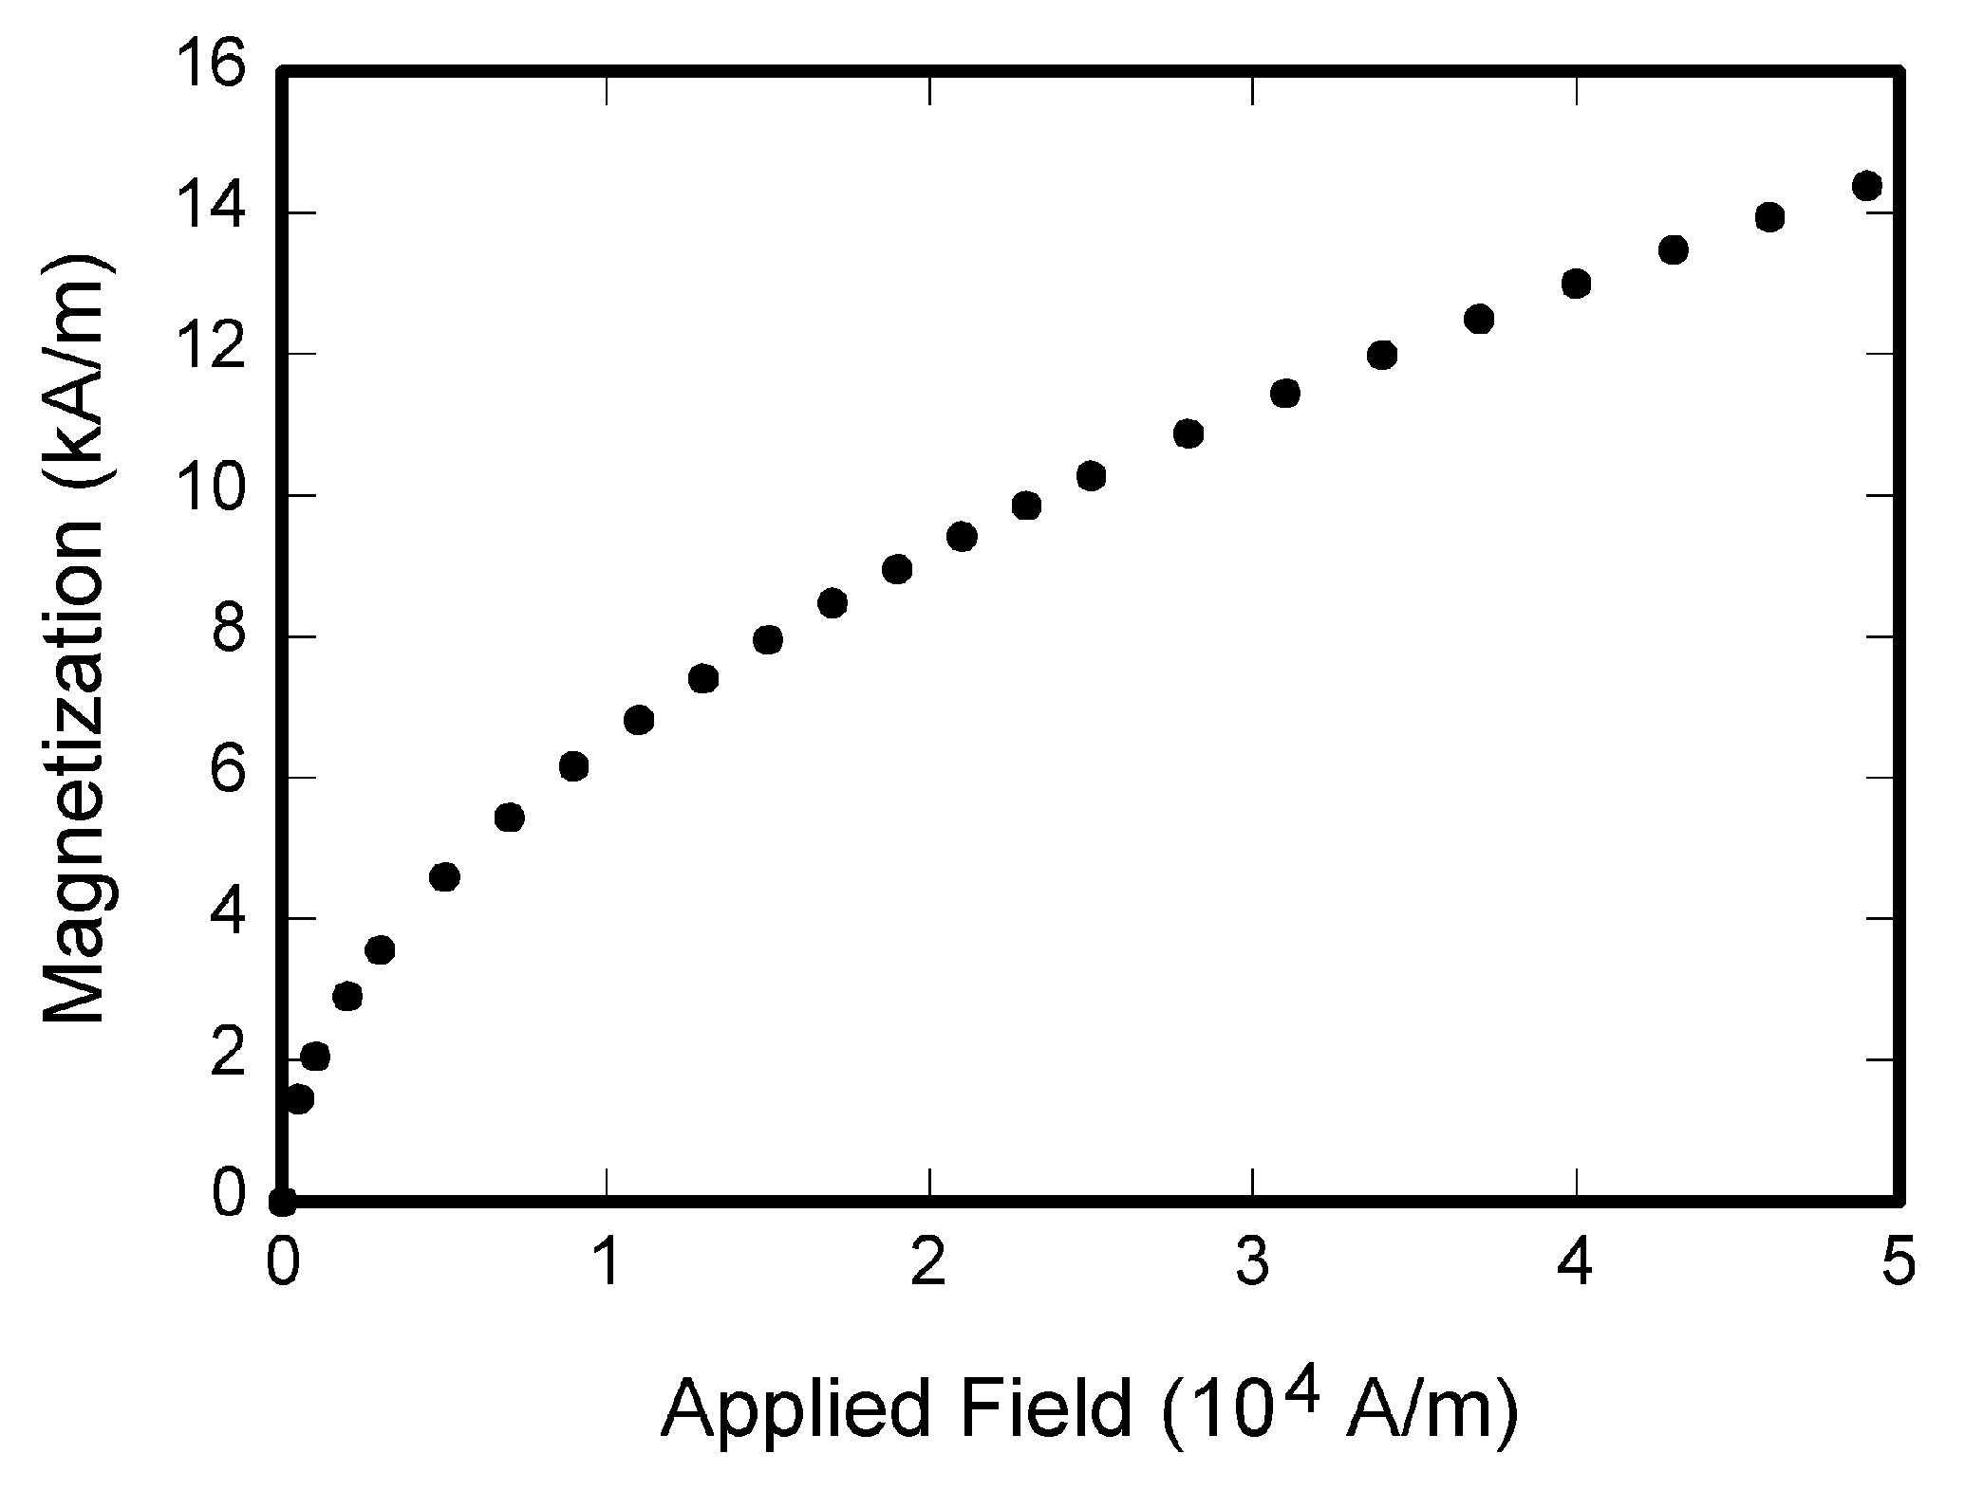
Fig. 1. Magnetization as a function of applied field

Equations
Use either the Microsoft Equation Editor or the MathType add-on for equations in your digests. Number equations consecutively with equation numbers in parentheses flush with the right margin, as in (1). First use the equation editor to create the equation. Then select the “Equation” markup style. Press the tab key and write the equation number in parentheses. To make your equation more compact, you may use the solidus (/), the exp function, or appropriate exponents. Use parentheses to avoid ambiguities in denominators. Punctuate equations when they are part of a sentence, as in
. (1)
Be sure that the symbols in your equation have been defined before the equation appears or immediately following. Refer to “(1),” not “Eq. (1)” or “equation (1)” except at the beginning of a sentence: “Equation (1) is… .”
Please confine equations to one column width and break equations at appropriate algebraic symbols.

Units
Use either SI (MKS) or CGS as primary units. SI units are strongly recommended. Avoid combining SI and CGS units, such as current in amperes and magnetic field in oersteds. If you must use mixed units, clearly state the units for each quantity in an equation.

Conclusion
A conclusion section is not required. Although a conclusion may review the main points of the paper, do not replicate the abstract in the conclusion. A conclusion might elaborate on the importance of the work or suggest applications and extensions.

References
Number citations consecutively in square brackets [1]. The sentence punctuation follows the brackets [2]. Multiple references [2], [3] are each numbered with separate brackets [2]-[3]. When citing a section in a book, please give the relevant page numbers [2]. In sentences, refer simply to the reference number, as in [3]. Do not use “Ref. [3]” or “reference [3]” except at the beginning of a sentence. Papers that have not been published should be cited as “unpublished” [4]. Papers that have been submitted for publication should be cited as “submitted for publication” [5]. Paper that have been accepted for publication but not yet specified for an issue should be cited as “to be published” [6]. Please give affiliations and address for private communications [7].
Use a space after authors’ initials. Capitalize only the first word in a paper title, except for proper nouns and element symbols. If you are short of space, you may omit paper titles.

Language
The use of grammar and spelling checker is strongly recommended. It is also suggested that you get the digest proof read by a native English-speaking colleague if you native language is not English.

References
- G. Eason, B. Noble, and I. N. Sneddon, “On certain integrals of Lipschitz-Hankel type involving products of Bessel functions,” Phil. Trans. Roy. Soc. London, vol. A247, pp. 529-551, Apr. 1955.
- J. Clerk Maxwell, A Treatise on Electricity and Magnetism, 3rd ed., vol. 2. Oxford: Clarendon, 1892, pp. 68-73.
- I. S. Jacobs and C. P. Bean, “Fine particles, thin films and exchange anisotropy,” in Magnetism, vol. III, G. T. Rado and H. Suhl, Eds. New York: Academic, 1963, pp. 271-350.
- B. Smith, “An approach to graphs of linear forms,” unpublished.
- J. Wang, “Fundamentals of erbium-doped fiber amplifiers arrays,” IEEE J. Quantum Electron., submitted for publication.
- E. H. Miller, “A note on reflector arrays,” IEEE Trans. Antennas Propagat., to be published.
- C. J. Kaufman, Rocky Mountain Research Laboratories, Boulder, CO, private communication, 2004.

