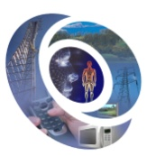 | EHE 2014  5th International Conference on Electromagnetic Fields, Health and Environment  24th - 26th April, 2014. Porto, Portugal
Paper Application Form

Please, complete this form and send it to: ehe2014-secretariado@apdee.org

Paper Details (one per paper)

Paper Title:

Author1:

Author2:

Author3:

Author4:

Author5:

Author6:

Corresponding Author:

Author Presenting the Paper:

Corresponding Author

SURNAME: |  | First Name:

Title: |  | Gender: | Male |  | Female

Position:

Affiliation:

Address:

Zip Code: |  | Country:

E-mail:

Phone: |  | Fax:

Author Presenting the Paper

SURNAME: |  | First Name:

Title: |  | Gender: | Male |  | Female

E-mail:

Date:.__________________ Signature: _________________________________________
(Please, complete this form and send it to: ehe2014-secretariado@apdee.org )

